 | 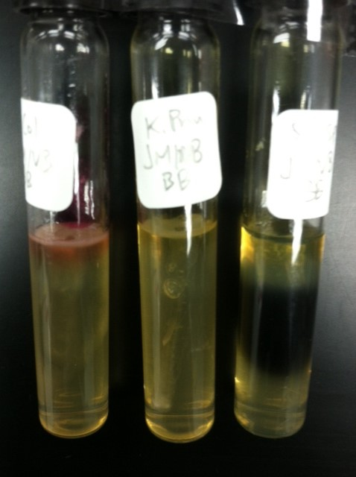
Indole  Motility  H₂S | E.coli Kleb.pnemuo Salmonella sp.  + (pink) neg neg  + (cloudy) neg +  Neg neg + (black ppt)

